Master AI Team Project Winter 20/21

E-Markt Fulda

## (Team 4)

# Milestone 4

# Product Summary

E-Markt Fulda is an application specially designed for the people directly associated with the Fulda University of Applied Sciences. People can buy and sell the products by leveraging this application. The main goal of designing this application is to provide students with the opportunity to get best products in cheaper price, as slightly-used products are mostly cheaper and fulfils the purpose. This application will also play an important role to bring all the people associated with Fulda University of Applied Sciences on a single platform. Especially, in these hard times when everybody wants to but cannot go outside, this application will prove itself to be a platform which helps everyone to get what they need without having an interaction with any human being. Users’ satisfaction was and is the ultimate goal of designing this application and to achieve it, we have provided the opportunity for the customer to chat with the seller to have all the questions answered before buying a product.

**Functionalities of E-Markt Fulda:**

1. **Login:** With the functionality of Login, only the staff and students of Hochschule Fulda can login with their passwords
2. **Sign Up/Registration:** Only the staff and students of Hochschule Fulda can register themselves in this app, as It would only be available for them.
3. **Home Page:** Home page contains all the products that are approved form admin, and available to sell with buttons on the right top for ‘Sell A Product’ and ‘Chat’ along with a search bar to search anything by name.
4. **Search Products:** Users can simply search anything by its name and if the user gives nothing in the input field, all products will appear as a result.
5. **Filter Products:** Users can filter searched results. They can filter by alphabetical order, price range, and product posting date.
6. **Post Product:** Users can post the product that he wants to sell and can upload multiple images of products.
7. **Product Details:** Users can check the details, description and images of the product that he/she wants to buy with a chat button so users can instantly start chatting with the seller.
8. **Admin User:** The admin user maintains the decorum of the website by managing users and products.
9. **Admin Product Approval:** Admin takes care about posting of the products and checks if everything is in order or not and then the approved product is shown.
10. **Chat With Seller:** The users can chat with the seller if he/she has any query regarding the product or is interested in the product

.

**URL of the product :**

**<http://gdsddata.s3-website-us-east-1.amazonaws.com/login>**

# Usability Test Plan

**Test Objective:**

The customer develops the perception back in the state of mind based on very first impression of a website. For this, the search functionality is selected to be tested because user searches for the product in the first go. The reason behind selecting this functionality is that it is going to be one of the mostly used functionalities of E-Markt Fulda. This function gives the desired result in the form of list containing all the products related to the user’s search. example, if a user writes Samsung in the search bar and clicks the search button, it is going to return all the products having Samsung in their name somewhere. It matches the strings and numbers with the products already available in database and returns the matched values. Furthermore, to be more precise, some of the filters are added to this search. If a user wants a product within a specific price range, he/she can simply apply the filters.

**Test Background and setup:**

The user lands on the primary page after searching for the URL, here he/she is asked for logging in or registering. The user will not be allowed to proceed further without. This is the starting point.

**Case 1:**

When the user, who wants to buy a product, lands on the primary page of E-Markt Fulda. The form appears in which user is required to put the credentials if he/she already has signed up, in case user has not signed up for E-Markt Fulda, he/she must sign up first to proceed further. After the user has logged in to E-Markt fulda, random products will appear on the home page where there will be a search bar, user can search for a specific product by putting a keyword or to be more specific, user can apply several filters afterwards, user also has the chance to chat with the seller to get more details about the product.

**Case 2:**

If a user wants to sell a product, again he/she will see a form on the primary page where he/she will be required to login or sign up in case user has not signed up previously. After the user has logged in to E-Markt Fulda, he/she can click on the Sell an Item button, where the user will provide the details of product/s which are to be sold, such as, pictures, description, and the price. At least, one picture is required for the ad. To be posted. After the user posts an ad., it goes to the admin panel to be approved by admin. As E-Markt Fulda is designed only people directly associated with Fulda University of Applied Sciences, the admin will confirm and the ad. Will be only posted if it is approved by the admin. As soon as the admin approves the ad., it will appear on the website. Keeping in mind that the admin has right to disapprove the request to sell a product.

**Intended Users:**

The target users for E-Markt Fulda are the people who are directly associated with Fulda University of Applied sciences. For this, it is mandatory for the user to use the email address ending up with “informatik.hs-fulda.de”. Any other email address will not be allowed to be used for signing up for E-Markt Fulda.

[**http://gdsddata.s3-website-us-east-1.amazonaws.com/**](http://gdsddata.s3-website-us-east-1.amazonaws.com/)

URL will be analyzed based on its safety and its accessibility, SSL protocol will not be employed here because Amazon Education does not provide it. The time will be then calculated which it takes to load into a browser.

What is to be measured?: The usefulness of the website will be measured to analyze how easier it is for the users to understand and leverage the website. The main goal is to make the website self-explanatory, if a user is stuck somewhere then he/she could easily find a way out. It will also be analyzed how good the experience of E-Markt Fulda is, as per users point of view.

**Usability Task description:**

The tester will be provided with the primary page with the form where he/she can login or sign up for E-Markt Fulda and will be asked to perform some tasks:

**Case 1:**

Search for an Apple Pencil which is posted not more than a week ago.

**Case 2:**

Search for a Samsung phone which costs between 200 Euros and 500 Euros.

**Measuring Effectiveness:**

* Are the users easily able to search for the product they searched for?
* Are the users easily able to search for exact products after applying the filters?

**Measuring Efficiency:**

* How long does it take for the user to search for the product followed by the keyword they put in the search bar?
* Are the users applying filters to look for products or just browsing through products on the home page?

**Questions/Feedback:**

* How easy it was to use the search bar function on the scale of 1 to 5?
* How easy it was to search for the exact product as per the applied filters on the scale of 1 to 5?
* How was your overall experience with the search function of our website on the scale of 1 to 5?

# QA Test Plan :

**Test Objectives:**

The main purpose of the given test plan is to test the core functionalities of the website.

**HW and SW setup:**

Here we will be testing the functionality using the following combinations of HW/SW:

|  |  |  |
| --- | --- | --- |
| **Device** | **OS** | **Browser** |
| MacBook Pro 2013 late | MacOS Big Sur | Safari |
| Motorola One Vision | Android 10 | Google Chrome |
|  |  |  |

**Feature to be tested:**

Register, Login, Product Search, Filters, Product Details, Chat, Sell, and Edit.

**QA Test Plan Table:**

|  |  |  |  |  |  |
| --- | --- | --- | --- | --- | --- |
| **Test #** | **Title** | **Description** | **Input** | **Expected Output** | **Result** |
| 1 | Register a new user | Users must be able to register at the primary page of E-Markt Fulda | 1. Click on the register button.  2. Provide the required information.  3. Click on the “Register” button. | The user will be landed on the home page of E-Markt Fulda. | PASS |
| 2 | Login to the website with correct credentials | Users must be able to login to E-Markt Fulda for buying and selling the products. | 1. Provide the username and password.  2. Click the login button. | After clicking the login button, user will land on the home page of E-Markt Fulda. | PASS |
| 3 | Search for the product | Users must be able to search for the product by putting a keyword in search bar | 1. Go to search bar on the homepage.  2. Put the keyword and press search button. | List of all the products will appear having the keyword in their title. | PASS |
| 4 | Apply filters | Users must be able to be more specific by applying filters in their search for the product. | 1. Go to search bar and click more filters.  2. Set the filters according to choice and click search. | List of all the products will appear according to the filters applied by. The user. | PASS |
| 5 | Product detail | Users must be able to see the description of the product they have searched for. | 1. Search for a product.  2. Click anywhere on the product. | The product description page will appear in which the description of the product will be provided by the seller. | PASS |
| 6 | Chat with the seller | Users must be able to chat with the seller and seller must be able to respond to the customer. | 1. Open the product description page of any product.  2. Click on the “Chat with seller” button. | A chat box will appear where customer can chat with the seller and seller will be able to respond. | PASS |
| 7 | Sell an item | Users must be able to post an item for sale on E-Markt Fulda website. | 1. Click on the “Sell an Item” button.  2. Provide all the required information, including pictures, description, and price.  3. Click “Post the Ad.” Button and wait for it to be approved by the admin. | An ad should be posted on the website and the user should be redirected to browse products page. | PASS |
| 8 | Edit the posted advertisement | Users must be able to edit the ad. They have already posted, including pictures, price, and details. | 1. Click on the “posted ads.” Button.  2. Click on “Edit” button.  3. Click on the “Save” button after changes are done. | The product details page with the changes will appear after the changes are made to the posted ad. | PASS |

**Code review**

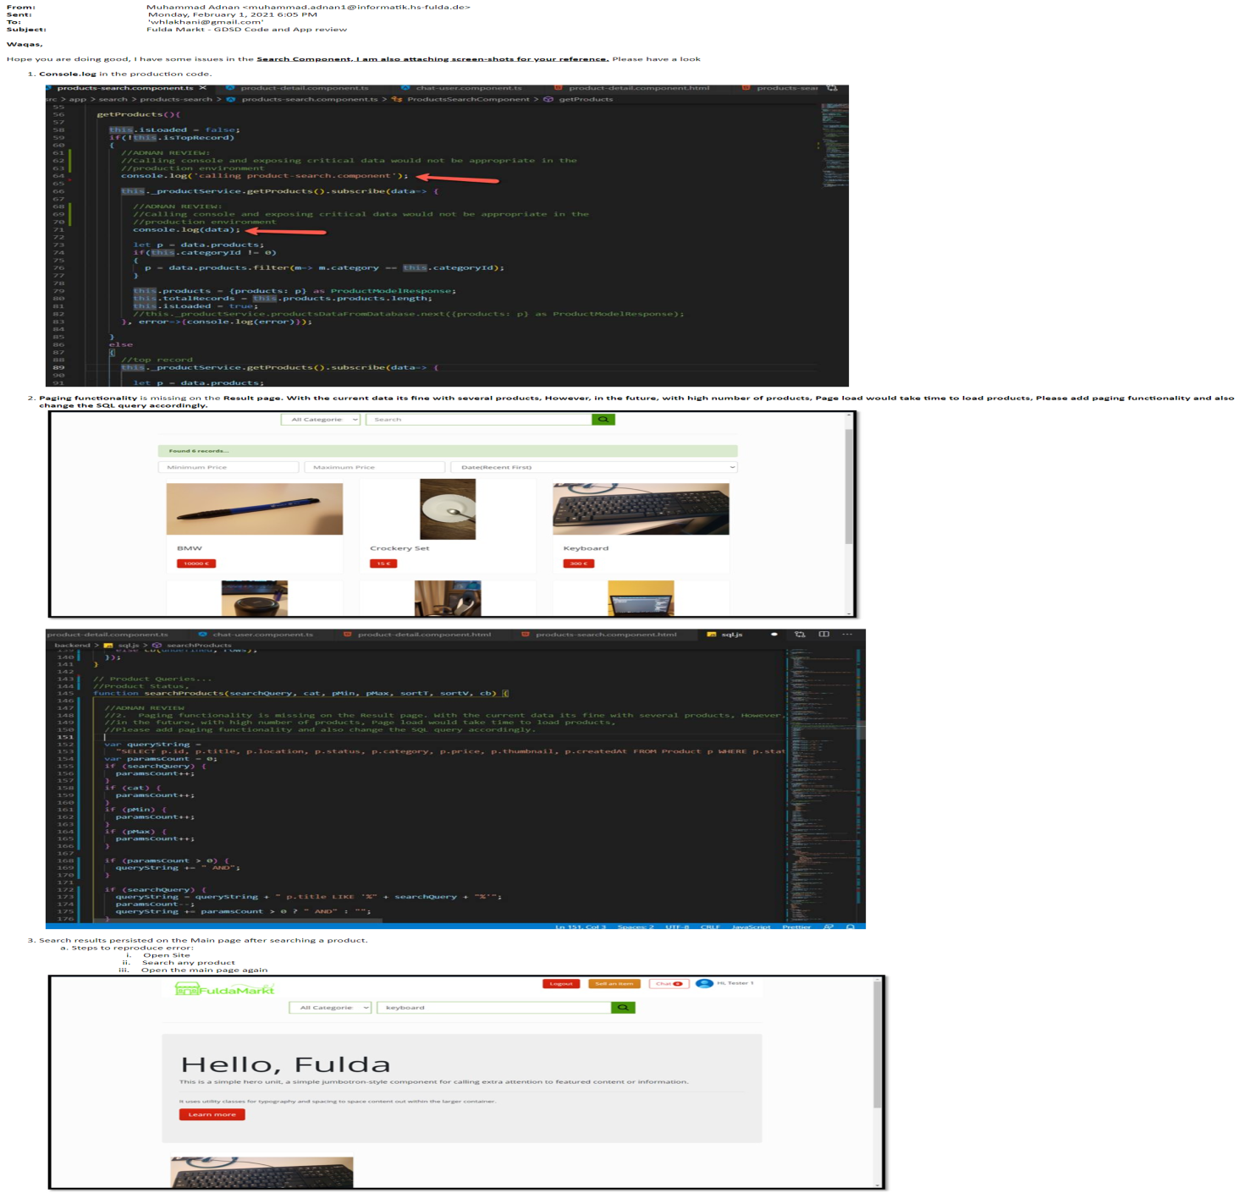

# Self-check on Security Best Practices

## Major Assets being protected

1. **Server Login credentials**
2. **Database**
3. **Deployed Application Code**

## Major threats for each Asset above and how they are protected

1. **Server Login credentials**
   1. Private Key Compromise - Private key is only accessible to one administrator who manages the server.
   2. Unauthorized SSH Access - SSH credentials to server is only known to one administrator.
2. **Database**
   1. Privilege abuse – Database has only one user who administers the database deployed in server.
   2. SQL Injection – SQL injection has been mitigated by using data sanitizing filtering for all search, signup, login, product and message posting forms inputs.
   3. Exploitation of Vulnerable, Misconfigured Databases – Database can not be accessed from the web or without first logging in using the SSH credentials of the server.
   4. Denial of Service – Server is deployed using Amazon web services which prevents the Denial-of-Service vulnerability.
   5. Storage media exposure – Media is stored on AWS EC2 instance and is called only from a server route which is only accessible to registered users of the application.
3. **Deployed Application Code**
   1. Complete code of Angular application is only available on Github to the authors and project manager of the application. Generated build is deployed on Amazon S3 storage for public access which is a compiled Javascript of the application.
   2. For the NodeJS application. Its hosted-on AWS EC2 instance and Node doesn’t allows to access files on port. Thus, server code is not accessible directly from URL. Node only allows registered routes to access through HTTP request and sends response accordingly.

**Confirmation of User Information Security:** All user supplied passwords are saved as encrypted values in the database.

**Confirmation of Input data validation:** Application codes validates,

1. Signup form – Emails for suffix, character limits and data type.
2. Login form – Validity of User Email and Password.
3. Product posting – Character limits for each form text inputs.
4. Search bar – Search inputs up to 40 alphanumeric characters.

# Adherence to original Non-functional specs

|  |  |  |  |
| --- | --- | --- | --- |
| No. | Non-Functional Requirement | Status | Notes (If any) |
| 1 | Application shall be developed, tested and deployed using tools and servers approved by Class CTO and as agreed in M0 (some may be provided in the class, some may be chosen by the student team but all tools and servers have to be approved by class CTO). | DONE |  |
| 2 | Application shall be optimized for standard desktop/laptop browsers e.g. must render correctly on the two latest versions of two major browsers | DONE |  |
| 3 | All or selected application functions must render well on mobile devices | DONE |  |
| 4 | Data shall be stored in the database on the team’s deployment server. | DONE |  |
| 5 | No more than 50 concurrent users shall be accessing the application at any time | DONE |  |
| 6 | Privacy of users shall be protected and all privacy policies will be appropriately communicated to the users. | DONE |  |
| 7 | The language used shall be English (no localization needed) | DONE |  |
| 8 | Application shall be very easy to use and intuitive | DONE |  |
| 9 | Application should follow established architecture patterns | DONE |  |
| 10 | Application code and its repository shall be easy to inspect and maintain | DONE |  |
| 11 | Google analytics shall be used (optional) | NOT DONE | Not Implemented as it was optional. |
| 12 | No e-mail clients shall be allowed. Interested users can only message to sellers via in-site messaging. | DONE |  |
| 13 | Pay functionality, if any (e.g. paying for goods and services) shall not be implemented nor simulated in UI. | DONE |  |
| 14 | Site security: basic best practices shall be applied (as covered in the class) for main data items | DONE |  |
| 15 | Media formats shall be standard as used in the market today | DONE |  |
| 16 | Modern SE processes and practices shall be used as specified in the class, including collaborative and continuous SW development | DONE |  |
| 17 | The application UI (WWW and mobile) shall prominently display the following exact text on all pages "Fulda University Software Engineering Fall 2020. For Demonstration Only” at the top of the WWW page. (Important so as to not confuse this with a real application). | ON TRACK |  |